**LAB 4**

**Q1) What are the values of the registers and the variables after each group of instructions in the following program.**

1. **Put the break point and notice the value of register in register window and write down the value of output (i.e register value) or attached the snips of each step.**











































1. **Also write interpretation of the each line of the following program and**

**Attach the output of the register window not console window!**

Interpretations written as comments:

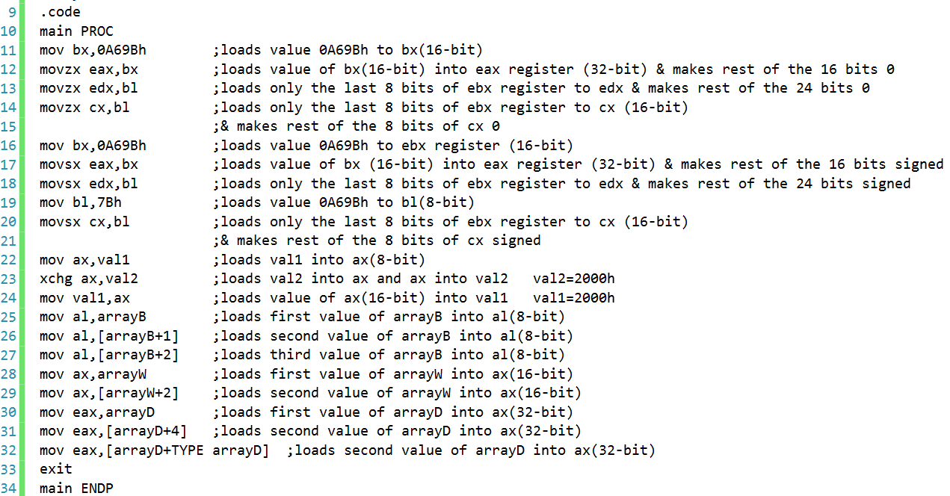

**Register window (final):**



**Q2) What are the values of the registers and the variables after each group of instructions in the following program.**

1. **Put the break point and notice the value of register in register window and write down the value of output (i.e register value) or attached the snips of each step.**



















































1. **Also write interpretation of the each line of the following program and**

**Attach the output of the register window not console window!**

Interpretations written as commands:

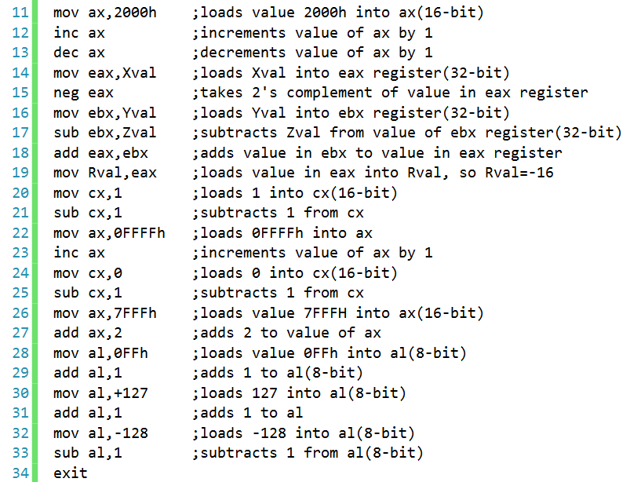

**Register window (final):**



**Q3) RUN the following program at emu8086 and notice the value of lower byte and higher byte register and status of CPU flag bit. Attach the output of running program. Also write or attached each step of output.**

Output and CPU flags:

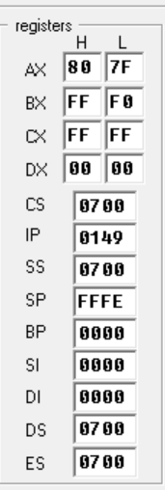 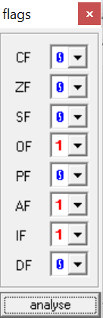

**Steps:**

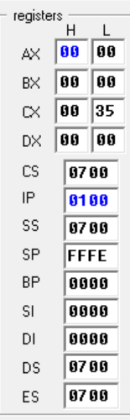 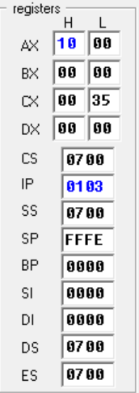 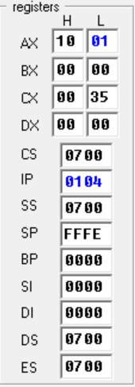 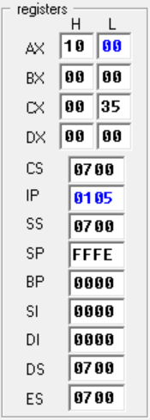 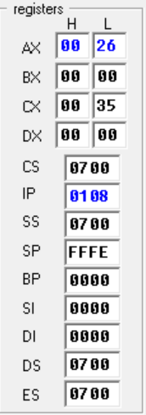

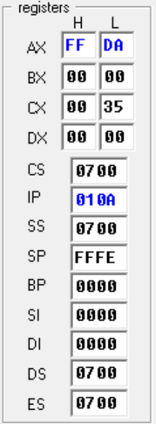 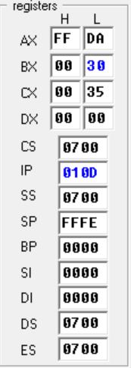 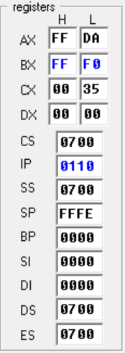 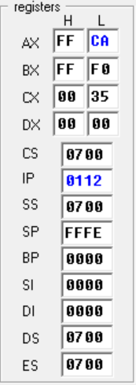 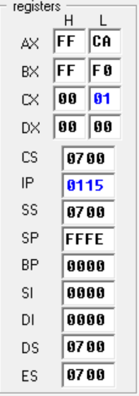

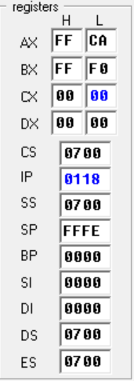 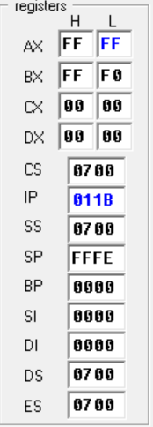 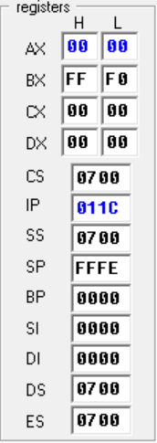 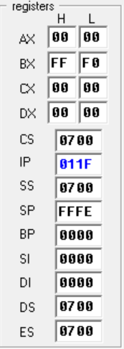 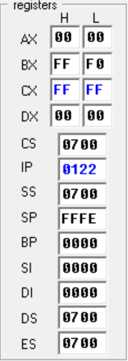

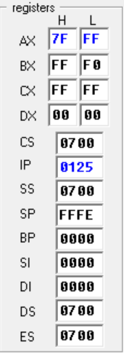 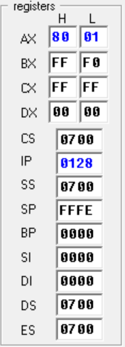 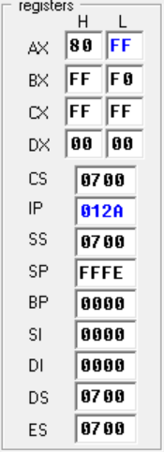 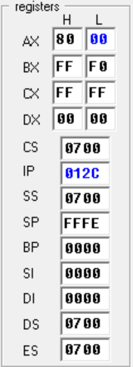 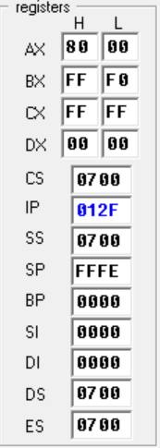

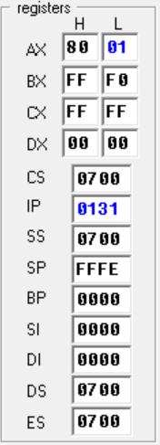 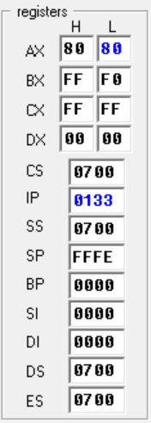 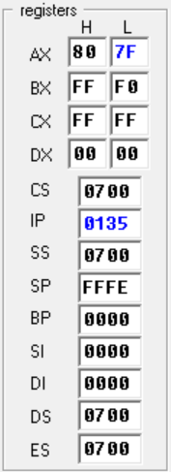

**Q4) Indicate whether or not each of the following instructions is valid OR not.Run the each instruction in .code segment and attached the snip. Register assume to any value. For example you may take ax=2 or any other integer.**

1. **add ax,bx** 🡪 **Valid**

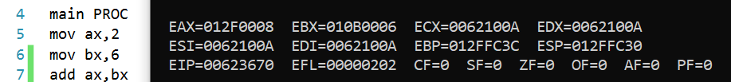

1. **add dx,bl** 🡪 **Invalid**

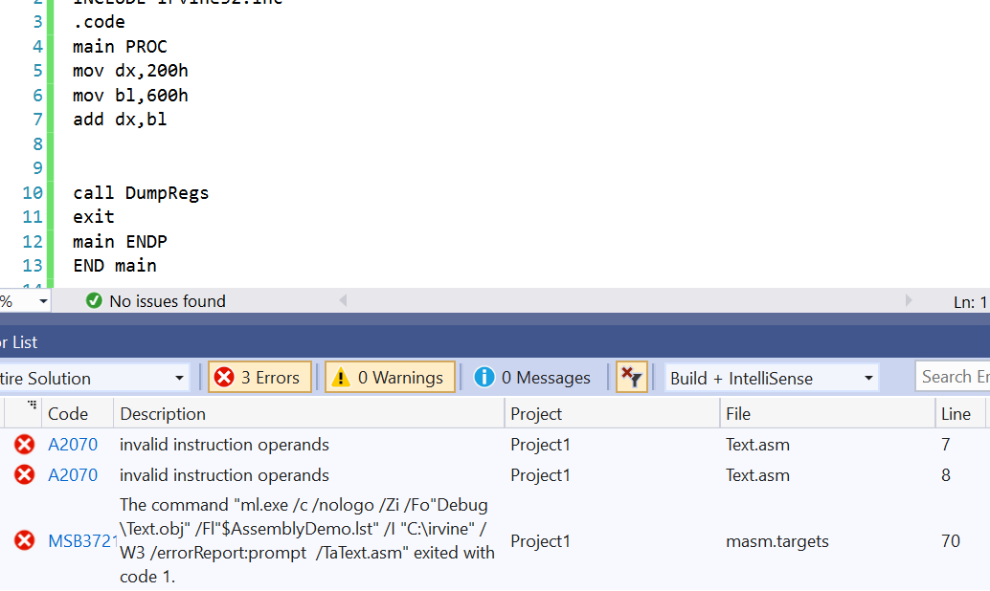

1. **add ecx,dx** 🡪 **Invalid**

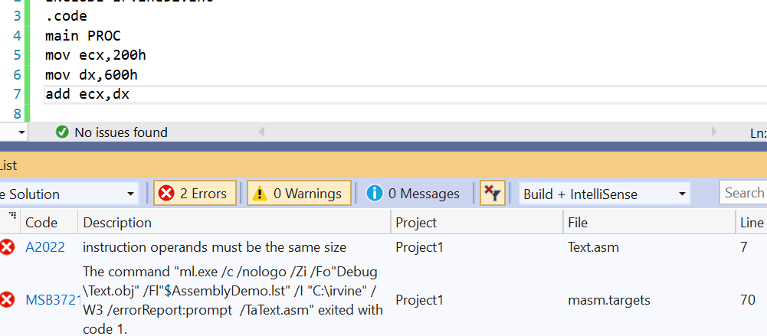

1. **sub si,di** 🡪 **Valid**

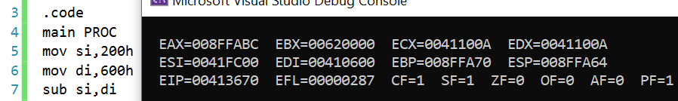

**e. add bx,90000 🡪 Invalid**

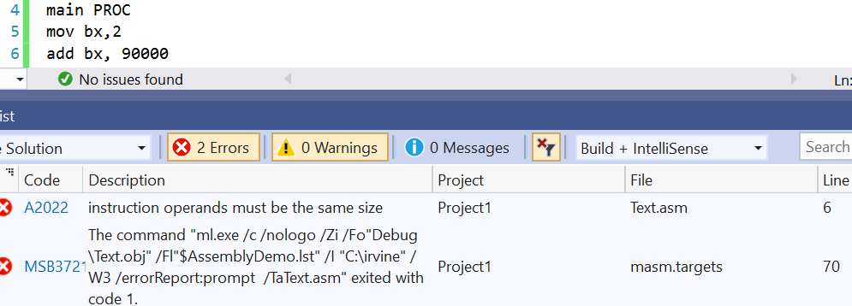

1. **sub ds,1** 🡪 **Invalid**

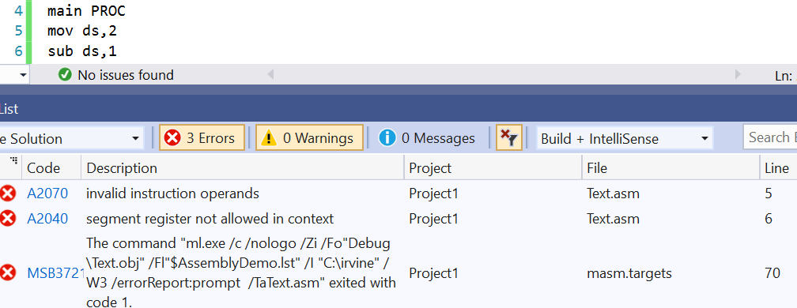

1. **dec ip** 🡪 **Invalid**

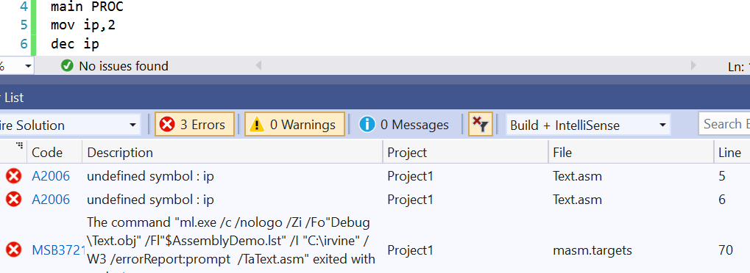

**h. dec edx 🡪 Valid**

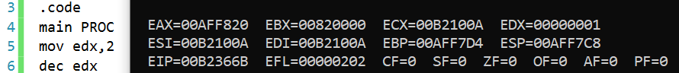

**i. add edx,1000h 🡪 Valid**

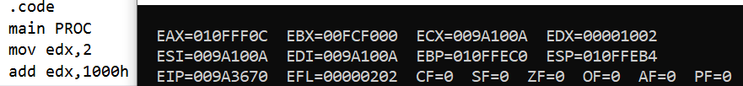

**j. sub ah,126h 🡪 Invalid**

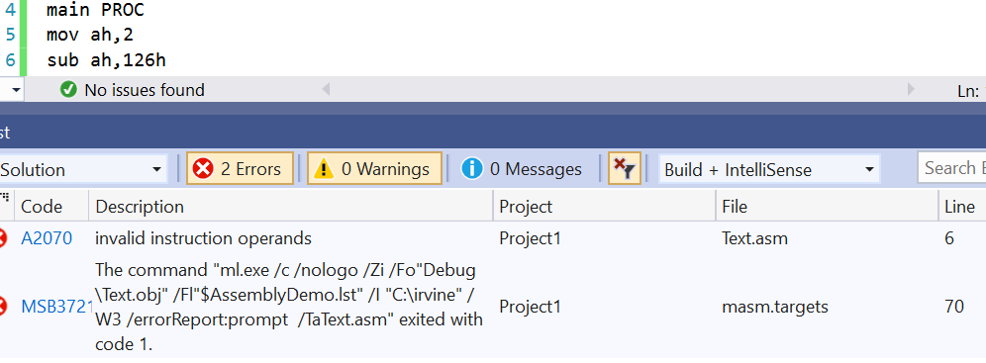

**k. sub al,256 🡪 Invalid**

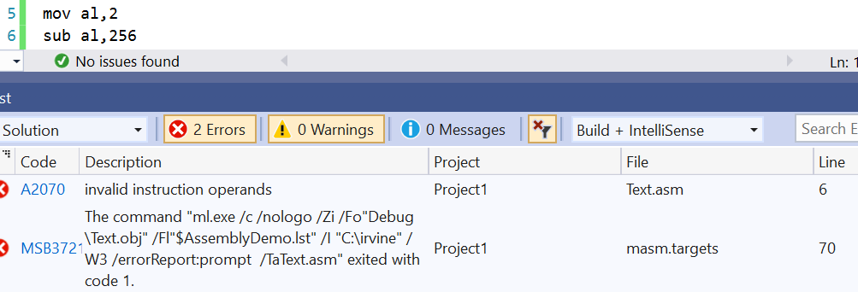

**l. inc ax,1 🡪 Invalid**

